iSMART: A Mobile QR-Code and ID Scan-Based ICT Equipment Borrowing, Monitoring, and Management System for Alitagtag National High School

Franck Iries D. Ais
Jay Angelo M. Marasigan
Cyrus Lee Q. Ramos
BSIE ICT – 4th year

Chapter 1
THE PROBLEM AND ITS BACKGROUND
This chapter shows the introduction that provides the overview of the study, background of the study, statement of the problem, and scope and limitations.

Introduction
The effective management of Instructional Information and Communications Technology (ICT) equipment has become increasingly important in schools, where devices such as computers, projectors, and multimedia tools support classroom instruction and digital learning environments. Efficient handling of shared ICT resources is necessary to ensure availability, prevent equipment loss, and maintain complete and accurate inventory documentation. Manual logbooks are widely recognized as prone to human error, delayed retrieval of information, and inconsistent record-keeping in educational and organizational settings (Hasan & Alam, 2021). Despite these limitations, local educational institutions, such as Alitagtag National High School, continue to rely on manual logging systems for tracking equipment. These limitations often lead to misplaced equipment, unrecorded borrowings, difficulty in monitoring real-time status, and challenges during inventory audits.
As digital transformation becomes essential in school operations, automated asset management systems offer a practical and scalable solution. Recent studies highlight that QR code–based tracking systems are efficient, cost-effective, and capable of improving accuracy and accountability in managing institutional resources (Choi & Lee, 2022). QR codes allow rapid access to equipment data through scanning, thereby reducing manual workload and providing real-time updates on borrowing and returning activities. Integrating this technology into the school’s equipment management process can streamline operations and enhance transparency. In response to the existing inefficiencies in Alitagtag National High School, this project aims to design and develop a Mobile QR-Code and ID Scan-Based ICT Equipment Borrowing, Monitoring, and Management System.
The system automates equipment tagging, borrowing and returning workflows, and transaction recording. It provides a secure and reliable digital management platform for administrators and property custodians who oversee the school's ICT equipment, while faculty members and students act as borrowers whose identity is verified through student or employee ID scanning at the point of every transaction. This design eliminates the need for borrowers to create and maintain separate user accounts while still ensuring full accountability and traceability of every borrowed item.
The system is developed as a mobile application installed as an Android Application Package (APK), built using standard web technologies (HTML, CSS, and JavaScript) and packaged for native Android deployment. The system is designed to run on Android smartphones and tablets running Android 8.0 (Oreo) or higher, with a rear camera of at least 8 megapixels and autofocus to ensure accurate QR code and student ID scanning. A stable internet connection is required because the system synchronizes data in real time with its cloud-hosted database. The application operates online, communicating with a cloud-hosted database (Supabase, built on PostgreSQL) to store and synchronize all records in real time. Because the system is installed on Android devices, the administrator and property custodian can process transactions directly from smartphones or tablets without needing to open a browser or remember a URL, providing a faster and more focused user experience than a typical web page.
By transitioning from manual processes to automated, cloud-based monitoring through an installed mobile application, the project seeks to improve accuracy, strengthen user accountability, reduce administrative burdens, and contribute to the modernization of ICT resource management within the school.

Background of the Study
The efficient management of Instructional Information and Communications Technology (ICT) equipment is vital in modern educational institutions, where hardware assets such as laptops, computers, and projectors directly support digital learning and classroom instruction. Systematically monitoring shared ICT assets ensures operational availability, mitigates asset loss, and maintains robust inventory documentation. Despite these operational demands, local educational institutions frequently rely on traditional, paper-based logbooks. Existing literature highlights that manual inventory processes are inefficient, time-consuming, highly susceptible to human error, and vulnerable to data loss or delayed record retrieval (Hasan & Alam, 2021). These limitations result in unrecorded borrowing transactions, misplaced equipment, lack of real-time visibility regarding item status, and substantial challenges during periodic inventory audits (Wijesena & Amarasinghe, 2023).
To address these systemic vulnerabilities, academic institutions are increasingly implementing digital asset management frameworks (Mohd Nasir et al., 2025). Recent empirical research indicates that Quick Response (QR) code technology, when paired with web-based database management systems, provides a highly scalable, accurate, and cost-effective tracking solution (Choi et al., 2025). By affixing unique scannable QR tags to individual equipment items, check-in and check-out procedures can be rapidly executed using mobile devices (Pabelona Jr. & Sermonia, 2025). This automated framework eliminates manual data entry errors, enables real-time status updates, enhances user accountability, and simplifies compliance with institutional auditing procedures (Dela Cruz et al., 2023).
The necessity for a technological intervention is underscored by current operational challenges at Alitagtag National High School. Preliminary data gathering indicates that while 86.4% of institutional respondents regularly handle or borrow instructional ICT equipment, 45.5% report the absence of a structured monitoring framework. Among those utilizing a tracking mechanism, 57.9% continue to depend on manual logbooks. Consequently, 50% of participants encounter difficulties in equipment tracking, 40.9% perceive the current procedure as excessively time-consuming, 36.4% report instances of missing or incomplete transaction records, and 31.8% experience scheduling conflicts and miscommunication regarding asset availability. Given the high borrowing frequency of high-value equipment—specifically laptops (54.5%) and projectors (40.9%)—the reliance on traditional manual recording system presents significant procedural delays and operational inefficiencies.
To resolve these localized operational inefficiencies, this study focuses on the design, development, and evaluation of a Mobile QR-Code and ID Scan-Based ICT Equipment Borrowing, Monitoring, and Management System for Alitagtag National High School. By automating equipment tagging, borrowing and returning workflows, and centralized transaction logging, the proposed system aims to minimize administrative workloads, enhance user accountability, ensure real-time data integrity, and establish a modern standard for institutional resource management.
The system is developed as an installed Android mobile application (APK) that runs online, it requires an internet connection to communicate with a cloud-hosted database (Supabase). This cloud architecture ensures that all asset records, borrower information, borrowing and return transactions, and audit logs are stored securely in a centralized location and can be retrieved from any device on which the application is installed. Because the application is installed natively on Android devices rather than accessed through a browser, custodians can launch it with a single tap from the home screen of their smartphones or tablets, making on-the-spot QR and ID scanning more efficient during high-volume transaction periods.
Objectives of the Study
This project aims to develop a Mobile QR-Code and ID Scan-Based ICT Equipment Borrowing, Monitoring, and Management System for the Instructional ICT Equipment of Alitagtag National High School.
1. Design a database-backed system that tags instructional ICT equipment with unique QR codes and stores relevant metadata, with the following features:
1.1. Admin and Custodian Login — The system provides secure authentication for two distinct roles: the Administrator, who manages user accounts and oversees the entire system, and the Property Custodian, who processes asset registration and transactions.
1.2. Equipment registration and description — Assets are registered with complete details including name, category, brand, model, serial number, location, condition, and a brief description, all stored in a cloud-hosted database.
1.3. Real-time equipment status — Each asset is dynamically classified as Available, Borrowed, Damaged, or Under Maintenance, with the status updating automatically as transactions occur.
1.4. Borrowing and returning transactions with time and date logs — Every borrow and return action is recorded with a precise timestamp, ensuring a complete and auditable transaction history.
1.5. Borrower identification through student or faculty ID scanning — For student borrowers, the system captures the name and Learner Reference Number (LRN) directly from the school ID, with the grade level manually entered by the custodian since it appears on the reverse side of the ID. For faculty borrowers, borrower details are manually typed by the custodian. This design eliminates the need for borrower accounts while ensuring accurate identification.
1.6. QR-code-based equipment lookup on the dashboard — A quick-scan tool on the dashboard allows the custodian to scan an asset's QR code to instantly retrieve its details, which is particularly useful when the item name is unknown.
1.7. Automated transaction logs with downloadable CSV reports — All borrowing and return activities are logged and can be exported as a CSV file from the Activity page for reporting and auditing purposes.
1.8. Due-date notifications — The system alerts the administrator or custodian through a numeric badge on the notification dropdown when borrowed assets are approaching or have exceeded their scheduled return date.
2. Develop the mobile application in accordance with the design, packaged as an Android Application Package (APK) for installation on Android smartphones and tablets;
3. Test the functionality of the project according to its design specifications; and
4. Evaluate the project's acceptability in terms of:
4.1. Compatibility
4.2. Functionality
4.3. Design
4.4. Accessibility
4.5. User-Friendly Interface

Significance of the Study
The findings of this project are expected to benefit various stakeholders within the institution. For the administration and property custodians, the system offers a real-time, centralized, and automated tool for asset tracking, thereby reducing the administrative burden associated with manual record-keeping and inventory audits. Because the system is an installed mobile application, custodians are not tied to a fixed desktop workstation — they can register assets, process borrow and return transactions, and scan QR and student IDs directly from a smartphone or tablet while moving around the campus. For faculty members, the system streamlines the process of requesting and borrowing ICT equipment, ensuring timely access to necessary instructional resources and minimizing delays caused by misplaced or unmonitored assets. Students likewise benefit from improved access to essential learning tools, as the system enhances equipment availability and provides a faster, more transparent borrowing and return process. Future researchers may utilize the developed system and its evaluation results as a foundational reference for further studies on asset management, particularly those involving QR code technologies or similar digital tracking solutions. Finally, the institution as a whole stand to gain from the project, as it supports ongoing efforts to modernize administrative workflows, optimize the utilization of technological investments, and align with global developments in digital campus management.

Scope and Limitation of the Study
The project centers on the design, development, and evaluation of a Mobile QR-Code and ID Scan-Based ICT Equipment Borrowing, Monitoring, and Management System specifically tailored for Alitagtag National High School.
The system's scope encompasses essential functionalities, including asset registration, QR code tagging, management of borrowing and return processes with ID-based borrower verification, real-time status monitoring, and the generation of automated transaction logs that can be exported in CSV format. The system also includes due-date notifications for assets that are approaching or have exceeded their scheduled return date, displayed as a numeric badge on the notification dropdown of the user interface.
Coverage is strictly limited to the non-consumable instructional ICT equipment of Alitagtag National High School, such as computers, laptops, projectors, monitors, and network devices. The system is designed for use by two primary user roles. The Administrator manages user accounts, including the creation and deletion of custodian accounts, oversees the entire system, and accesses all reports and transaction logs. Property Custodian registers assets, processes borrow-and-return transactions using QR and ID scanning and monitors real-time equipment status.
Faculty members and students act as borrowers but do not create or use system accounts. Instead, their student or employee IDs are scanned and recorded by the custodian or administrator during each borrow and return transaction, ensuring accurate borrower identification and full accountability. For student borrowers, the scan captures the name and Learner Reference Number (LRN) from the ID, with the grade level manually entered by the staff since it appears on the reverse side of the school ID. For faculty borrowers, borrower information is manually typed by the custodian. This design was chosen intentionally to eliminate the friction of account creation and password management for hundreds of students and faculty members.
The system is developed as an installed Android mobile application, packaged as an Android Application Package (APK) for installation on Android smartphones and tablets. The application is online, requiring a stable internet connection to communicate with its cloud-hosted database (Supabase). All asset records, borrower information, and transaction logs are stored in the cloud, ensuring that the administrator and custodian always see the most current state of the inventory regardless of which device the application is installed on.
The system's acceptability will be evaluated based on five criteria: compatibility, functionality, design, accessibility, and user-friendly interface, among campus faculty and students.
However, the study is explicitly limited as it excludes other institutional assets such as furniture and supplies, complex financial modules such as depreciation and procurement, long-term impact analysis or comparative studies, and any overhaul of the existing campus network infrastructure. It also excludes student self-registration and independent borrower logins, as the borrowing workflow is intentionally designed around staff-assisted QR and ID scanning. Furthermore, QR code generation and printing are identified as planned future enhancements rather than part of the current implementation scope. The system is also not designed for offline use — because it relies on real-time synchronization with a cloud-hosted database, it requires an active internet connection to function. iOS support is also outside the scope of the present study, as the current deployment targets Android devices only.

Chapter 2
REVIEW OF RELATED LITERATURE AND STUDIES
This chapter shows the related literature for both independent and dependent variables of the study.

The Necessity of Digital Asset Management in Education
The management of physical assets in educational institutions has undergone a necessary modernization, moving away from labor-intensive manual methods, as observed by O’Connell and Davies (2024). The core motivation for this shift is rooted in the strategic goal of resource optimization and accountability, a necessity further highlighted by Estrada (2024). Research indicates that ICT integration in educational administration significantly enhances administrative efficiency, allowing personnel to move from routine, time-consuming tasks to more strategic planning, a key finding supported by Choi and Lee (2022) and O’Connell and Davies (2024). Estrada (2024) emphasizes that for universities, where large volumes of equipment are shared across multiple departments, a robust system is vital for reducing losses and theft, improving asset utilization, and simplifying loan and return management between staff and students. Furthermore, Hasan and Alam (2021) and O’Connell and Davies (2024) both underscore that automated systems provide detailed insights into asset utilization, which is crucial for maximizing the use of existing resources and preventing unnecessary, duplicate purchases, ultimately leading to substantial cost savings.
QR Code Technology in Asset Tracking
QR codes are now globally recognized as a superior alternative to traditional barcodes in many inventory applications due to their high information storage capacity and resilience to damage, a view advocated by Choi and Lee (2022). The primary advantage of utilizing QR codes in an asset management system is the ability to enable real-time data acquisition and tracking, a benefit highlighted by Dela Cruz and Garcia (2023). Choi and Lee (2022) explain that by simply scanning a code using a mobile device, users can instantly retrieve, or update linked asset profiles, ensuring that the inventory data is always accurate and current. This streamlined interaction enhances productivity by minimizing the time spent on manual data entry and searching for equipment details, which Dela Cruz and Garcia (2023) suggests is particularly beneficial in dynamic environments like computer laboratories and equipment pools. Crucially, developmental studies, such as the one conducted by Choi and Lee (2022), have successfully implemented QR code-based tracking in technology workshops, demonstrating that the system's technical features are reliable and useful in providing quick and accurate inventory management. Recent implementations in educational resource management emphasize that integrating student or staff ID card scanning with item tracking significantly improves audit trails, ensures strict user authentication, and prevents unauthorized borrowing transactions (Oyerinde et al., 2025). This dual-scanning approach, combining asset QR codes with borrower ID verification, forms the technical foundation of the present study, where the custodian scans the student's or faculty member's ID to establish borrower identity and scans the asset QR code to confirm the item being transacted. Unlike traditional systems that require borrowers to log in with their own credentials, the present system places both scans in the hands of the custodian, which eliminates the need for borrower accounts while preserving full traceability. This design choice reflects the practical realities of a public high school where students may not have institutional email addresses and where minimizing login friction is essential for adoption.

Real-Time Monitoring and Reporting
Estrada (2024) identifies the capability for real-time monitoring and automated reporting as a critical component of modern asset management. O’Connell and Davies (2024) state that digital systems, unlike spreadsheets, maintain a constantly updated, transparent inventory of every asset under the institution's control. Hasan and Alam (2021) note that this capability is instrumental in ensuring regulatory compliance and simplifying audit preparations. Choi and Lee (2022) and Estrada (2024) both assert that the system’s ability to generate automated reports on overdue equipment, inventory status, and usage patterns reduces the administrative workload and provides administrators with the necessary data to make informed decisions regarding maintenance and future investments. Estrada (2024) further concludes that the integration of these features contributes to a culture of greater transparency and trust, as all transactions and asset statuses are traceable and auditable.
A web-based inventory management system with QR Code tagging developed for a university in 2023 by Dela Cruz and Garcia demonstrated a direct link between digitalization and improved security (Dela Cruz & Garcia, 2023). The researchers noted that replacing physical copies of records, which were prone to being misplaced, with a digitized system significantly reduced the time and energy required for inventory managers to fulfill their duties, creating a less stressful and more manageable process (Dela Cruz & Garcia, 2023). Similarly, research from 2022 on the Design and Evaluation of an Innovative Mobile Solution: QR Code-based Inventory Monitoring System by Choi and Lee reported high user satisfaction scores in areas like accuracy, efficiency, and functionality (Choi & Lee, 2022). This study confirmed that integrating QR code scanning via mobile devices provides on-the-go accessibility and enhances control, ultimately optimizing inventory processes and minimizing errors (Choi & Lee, 2022). Another study focusing on the application of asset management software in schools confirmed that modern systems promote enhanced accountability by linking specific assets to responsible users (Estrada, 2024). This heightened sense of responsibility among both students and teachers leads to reduced losses and damages, reinforcing the importance of a clear digital trail facilitated by automated tracking technologies like QR codes (Estrada, 2024). These findings collectively support the premise that a transition to an integrated, QR-code based system is a necessary and proven solution for addressing the equipment management challenges at the Alitagtag National High School.
In the present study, the principles of real-time monitoring and reporting are realized through the system's cloud-based architecture, which synchronizes asset statuses and transaction logs across all connected devices the moment a scan is processed. The Activity page consolidates these transactions into a chronological, downloadable CSV log, directly addressing the literature's emphasis on automated, auditable reporting (Estrada, 2024; Hasan & Alam, 2021).

Compatibility
System compatibility is defined as the degree to which a software application can function across multiple hardware setups, operating systems, and browser environments without experiencing errors or performance degradation (Kim & Park, 2023). In educational institutions where users rely on diverse hardware devices—ranging from older desktop computers to modern smartphones—cross-platform compatibility is essential for software adoption (O’Connell & Davies, 2024). Pabelona Jr. and Sermonia (2025) note that web-based systems utilizing responsive design frameworks ensure seamless operation across varied screen sizes and operating systems. Ensuring compatibility reduces technical barriers and eliminates the need for expensive hardware upgrades, making automated asset systems viable in public school environments (Dela Cruz & Garcia, 2023). This consideration is particularly relevant to the present study, where the system is developed as an installed mobile application for Android devices, packaged as an APK for direct installation on smartphones and tablets. Although the application is built using standard web technologies (HTML, CSS, and JavaScript), it is delivered to users as a native Android app, eliminating the need for browser navigation and providing a focused, app-like experience. The application runs online, communicating in real time with a cloud-hosted database, which allows the same data to be synchronized across multiple installed copies of the app on different devices. This design ensures that the school's custodial staff can access the system from any Android device without being tied to a specific workstation.

Functionality
Measures whether a system effectively performs its intended capabilities and satisfies user specifications under defined operational conditions (Kim & Park, 2023). In asset monitoring software, key functional indicators include automated QR code scanning, accurate transaction logging, real-time database updates, and role-based access control (Choi & Lee, 2022). According to Wijesena and Amarasinghe (2023), high functional precision minimizes data entry errors, prevents unrecorded item loans, and ensures that records accurately reflect real-time physical inventory. Evaluating system functionality guarantees that the software reliably automates check-in and check-out procedures for faculty, administrators, and students (Estrada, 2024). In the present study, functionality is assessed through the system's ability to accurately capture borrower identity via ID scanning, record borrow and return transactions with timestamps, update asset availability in real time across a cloud-synchronized database and generate downloadable CSV transaction logs from the Activity page. These features directly reflect the key functional indicators identified in the literature — automated scanning, accurate transaction logging, real-time database updates, and role-based access control (Choi & Lee, 2022).

Design
System design encompasses the structural layout, visual aesthetics, color hierarchy, and graphical organization of the user interface (Kim & Park, 2023). A well-structured layout minimizes cognitive load and allows users to locate critical functions—such as dashboards, inventory tables, and transaction logs—without confusion (Nguyen & Williams, 2022). Modern web applications utilize structured CSS grid layouts and intuitive visual elements to present complex data clearly (Nguyen & Williams, 2022). Clear visual cues and consistent design schemes improve user engagement and decrease task completion time during routine asset checks (Sukron et al., 2024). In the present study, design is evaluated through the consistent visual identity of the iSMART mobile application, the clarity of the asset card layout that groups asset metadata into easily scannable rows, the prominence of the QR and ID scanning zones on the borrow and return pages, and the legibility of the dashboard statistics and notification badges. The interface adopts a card-based, mobile-first layout with a fixed bottom navigation bar, optimized for one-handed use on Android smartphones and reflecting modern mobile application design conventions (Nguyen & Williams, 2022).

Accessibility
Measures how easily users with varying levels of technical proficiency or device availability can access and navigate system features (Kim & Park, 2023). In educational institutions, ensuring round-the-clock accessibility enables users to check asset availability remotely prior to physically requesting items (O’Connell & Davies, 2024). Web applications built on standard web standards ensure that students and faculty members can interact with the borrowing platform on personal or institutional devices with equal ease (Nguyen & Williams, 2022). Broad accessibility fosters inclusive digital campus operations and promotes consistent system adoption across all grade levels (Mohd Nasir et al., 2025). In the present study, accessibility is assessed by the system's availability as an installed Android application that can be launched directly from the home screen of a smartphone or tablet, its online cloud-based architecture that synchronizes data across all installed devices, and its design for use by custodians regardless of their physical location on campus. Because the application is installed natively rather than accessed through a browser, it does not require users to remember URLs, manage bookmarks, or navigate browser interfaces, reducing the cognitive load of operating the system during busy transaction periods. The tradeoff is that the application requires an active internet connection to function, since its data is stored in the cloud rather than on the device itself.

User-Friendly Interface
Evaluates the simplicity, clarity, and comfort experienced by users when interacting with an application interface (Kim & Park, 2023). Interfaces featuring plain language, clear instruction prompts, and instant confirmation alerts build user confidence and reduce operational mistakes (Wijesena & Amarasinghe, 2023). Dela Cruz and Garcia (2023) emphasize that user-friendly design is vital in school environments where users possess varied levels of technological familiarity. Providing straightforward workflows for equipment scanning and profile management ensures higher user satisfaction and long-term compliance with institutional borrowing procedures (Estrada, 2024). In the present study, the user-friendly interface is evaluated through the intuitiveness of the borrow and return flows, the clarity of status indicators on asset cards (Available, Borrowed, Damaged, Under Maintenance), the ease of accessing the CSV export function on the Activity page, and the responsiveness of the notification badge for due-date alerts. The interface uses plain language, consistent iconography, and immediate visual feedback after every action, reducing the learning curve for custodians with varying levels of technical familiarity.

Supabase (Cloud Database and Backend Service)
Supabase is an open-source Backend-as-a-Service (BaaS) platform built on top of PostgreSQL that provides database, authentication, and real-time subscription services through a unified application programming interface. It offers a relational database model with row-level security, real-time listeners, and RESTful and GraphQL endpoints, making it suitable for modern mobile applications that require secure, cloud-hosted data management without the overhead of maintaining a custom backend.
In the present study, Supabase serves as the cloud-hosted database and authentication backbone of the iSMART mobile application. It stores all asset records, categories, brands, locations, student data, borrowing transactions, return transactions, audit logs, and user accounts. Its real-time capabilities support the live updating of asset statuses and dashboard statistics whenever a scan is processed, while its authentication service secures the login process for administrators and property custodians. Because Supabase is accessed over the internet, the iSMART application functions as an online mobile app — all data is stored and synchronized in the cloud rather than on the local device, ensuring that the administrator and custodian always see the most current state of the inventory regardless of which device the application is installed on.

HTML (Hypertext Markup Language)
HTML is essential in the creation of a website and forms the structural foundation of web technologies, including those used in the iSMART mobile application (Nguyen & Williams, 2022). Its tags allow developers to construct well-organized sections, headings, paragraphs, and lists, which improve readability and accessibility (Nguyen & Williams, 2022). Furthermore, HTML supports the incorporation of multimedia elements, including videos and interactive graphics, thereby enhancing engagement and interactivity (Nguyen & Williams, 2022). Through its hyperlinking features, HTML facilitates smooth navigation between pages and external resources, contributing to a connected learning experience (Nguyen & Williams, 2022). Additionally, HTML accommodates responsive design techniques, ensuring that content is optimally displayed across various devices and screen sizes (Nguyen & Williams, 2022). It also takes into account accessibility considerations, simplifying the process of creating inclusive learning experiences for users with disabilities (Nguyen & Williams, 2022). Moreover, the combination of HTML with CSS and JavaScript empowers developers to improve visual design, interactivity, and dynamic functionality (Nguyen & Williams, 2022). The versatility and compatibility of HTML render it an essential element in the development of a learning application, enabling structured content, multimedia integration, interactivity, accessibility, and engaging learning experiences (Nguyen & Williams, 2022).

CSS (Cascading Style Sheet)
Cascading Style Sheets is a robust technology that greatly impacts website development (Nguyen & Williams, 2022). It enables developers to specify the visual styling of an application, ensuring a uniform and aesthetically pleasing design across various devices (Nguyen & Williams, 2022). CSS supports responsive design, allowing the application to seamlessly adjust to different screen sizes and devices, thereby enhancing the learning experience (Nguyen & Williams, 2022). It offers layout properties and techniques to construct organized interfaces, which simplifies navigation and interaction for users (Nguyen & Williams, 2022). Moreover, it aids in branding and customization, preserving a cohesive visual identity (Nguyen & Williams, 2022). CSS empowers developers to design visually attractive, responsive, and customizable interfaces, which contributes to a captivating and effective learning environment (Nguyen & Williams, 2022).

JavaScript
JavaScript is a flexible, high-level programming language that is extensively utilized for developing interactive and dynamic applications across various platforms (Nguyen & Williams, 2022). In the context of Android and web-based educational applications, JavaScript allows developers to create responsive user interfaces, manage real-time interactions, and effectively incorporate multimedia elements (Nguyen & Williams, 2022). Its event-driven and asynchronous programming features facilitate smooth performance, efficient data management, and seamless communication with servers or APIs (Nguyen & Williams, 2022). When combined with frameworks and libraries such as React Native, Node.js, or Ionic, JavaScript enhances the development of cross-platform applications that are modular, scalable, and easy to maintain (Nguyen & Williams, 2022). Moreover, JavaScript offers powerful tools for debugging, testing, and optimizing application performance, enabling developers to create engaging, interactive, and user-friendly learning experiences (Nguyen & Williams, 2022).
Local Studies
Local research conducted in the Philippines consistently demonstrates the technical viability and strong user acceptance of moving from manual asset tracking to automated, QR-code-based inventory and borrowing systems, especially in the educational sector. These local insights are vital for the implementation of the proposed system at Alitagtag National High School.
Dela Cruz and Garcia (2023), in their study on a mobile-based inventory management system for a Philippine university, illustrated that the use of QR code generation significantly improved data accuracy and security for item tracking. They also observed that the system effectively decreased the time and effort needed for inventory managers when compared to labor-intensive manual record-keeping, thereby validating the efficacy of the mobile-based, QR-tagged method in a local university context.
The research conducted by Choi and Lee (2022), which examined a QR code-based system in a technology workshop, demonstrated significant technical reliability. Their system successfully passed all necessary evaluations and garnered high ratings regarding usefulness, and information quality. This study validated the effectiveness of QR code scanning for real-time monitoring and notifications, particularly aiding laboratory assistants and faculty within a specialized technical setting.
In a separate study, Estrada (2024) focused on the application of digital borrowing management, reporting high levels of user satisfaction in critical areas such as accountability, efficiency, and functionality. Their results affirm the substantial advantages of incorporating automated tracking for on-the-go access and improved equipment management, which is vital for reducing errors in environments with shared equipment.

Synthesis
Based on the comprehensive review of both international and local studies, the following synthesis highlights the key insights and formally identifies the research gap addressed by the current investigation. Previous studies, both global and domestic, consistently confirm the technical reliability and significant benefits of digitalizing asset management (O’Connell & Davies, 2024; Choi & Lee, 2022). Hasan and Alam (2021) and Estrada (2024) confirmed globally that digital systems improve accountability and reduce manual workload, while local studies (Dela Cruz & Garcia, 2023) provide specific evidence within the Philippine context. These studies collectively confirm that systems utilizing QR code tagging and mobile scanning successfully enhance data accuracy, security, operational efficiency, and user satisfaction compared to traditional methods (Choi & Lee, 2022; Estrada, 2024). In addition, local research (Dela Cruz & Garcia, 2023) confirms that these systems are highly usable and technically reliable when implemented within the operational and network constraints of Philippine academic and technical institutions. Their findings provide a strong foundation for the feasibility of the current project.
Furthermore, existing literature rarely addresses borrowing workflows in which the borrower does not create a system account but is instead identified entirely through staff-assisted ID scanning, as is the case in the present system. Most prior studies assume that borrowers log in with their own credentials, which is not practical in a public high school setting where students may not have institutional email addresses or consistent device access. Additionally, while many existing systems are deployed as traditional web applications accessed through a browser, the present study delivers the system as an installed Android application (APK), providing a more focused and mobile-friendly user experience that better suits the on-the-go nature of custodial work.
However, the difference lies in the specific integrated focus and contextualized application. While prior studies have addressed either general inventory management (Dela Cruz & Garcia, 2023) or specific tracking (Choi & Lee, 2022), there is a notable lack of studies focusing on the specific, dual requirement of a Mobile QR-Code and ID Scan-Based ICT Equipment Borrowing, Monitoring, and Management System implemented and evaluated within an institution like Alitagtag National High School. Therefore, the research gap identified in this review is the lack of a localized, integrated system that specifically merges real-time Instructional ICT asset monitoring with a formal, administrator/student/faculty borrowing management module, which is then evaluated strictly according to the perceived functionality by the target users at the Alitagtag National High School. The present study addresses this gap by developing and evaluating a system uniquely tailored to the specific non-consumable instructional ICT asset list and user roles of the Alitagtag National High School.

Research Paradigm
This study shows the Input-Process-Output (IPO) Model. The model illustrates the research flow – the requirements, activities, and output objectives of the application.
INPUT

1. Identified Challenges
a. Manual logbook errors
b. Lack of real-time monitoring
c. Poor accountability in borrowing

2. Software Requirements
a. Programming Language
• HTML
• CSS
• JavaScript
b. Database
• Supabase (Cloud / PostgreSQL)
c. Packaging Tool
• Capacitor (APK Build)

3. Hardware Requirements
a. Development Hardware
• Computer: Windows 8+, 4 GB RAM, 2.20 GHz, 500 GB
• Android test device: Android 8.0+, 8 MP camera
b. Deployment Hardware
• Android smartphone/tablet (Android 8.0+)
• 2 GB RAM, 16 GB storage
• Rear camera: 8 MP+ with autofocus
• Wi-Fi / mobile data connection
PROCESS

Waterfall Development Methodology

- Requirement
- Analysis
- Design
- Coding and Implementation
- Testing
- Evaluation
OUTPUT
iSMART: A Mobile QR-Code and ID Scan-Based ICT Equipment Borrowing, Monitoring, and Management System for Alitagtag National High School

EVALUATION

- Compatibility
- Functionality
- Design
- Accessibility
- User friendly interface

Figure 1. The Research Paradigm
The research paradigm for this project is based on the Input-Process-Output (IPO) model, which systematically outlines the development and evaluation of the Mobile QR-Code and ID Scan-Based ICT Equipment Borrowing, Monitoring, and Management System for Alitagtag National High School. This model ensures the systematic design, development, and assessment of the final product.
The Input phase identifies the essential requirements, existing conditions, and initial data needed to design and develop the system. This stage encompasses the Requirements Analysis, which involves documenting the limitations of the existing manual borrowing and inventory system, including the forms and logbooks currently in use, and defining the necessary user requirements from faculty, students, administrators, and property custodians. It also includes the assessment of Technical Feasibility, covering hardware, software, and personnel, and the collection of instructional ICT equipment and asset register data.
The software requirements identified for the system include HTML, CSS, and JavaScript as the core development technologies, Supabase (a PostgreSQL-based cloud database) as the primary data storage and authentication service, and a mobile application packaging tool (such as Capacitor) to compile the web technologies into an installable Android APK. The hardware requirements include an Android smartphone or tablet connected to the internet for the custodian's use, and a computer set with a minimum operating system of Windows 8, 4 GB of memory, a 2.20 GHz processor, and 500 GB of storage for development.
For the Process phase, the Waterfall Model of the System Development Life Cycle (SDLC) is utilized to structure the system's development, guiding the transformation of the Input requirements into the intended Output. This systematic methodology begins with requirement analysis to define the functional and non-functional specifications. This is followed by the Design phase, which converts these requirements into a system blueprint, including system architecture, database design, and User Interface/User Experience (UI/UX) mock-ups. Next is the implementation/coding phase, involving the actual programming and development of the core modules. The fourth step is testing, where unit and system integration testing are performed to check for bugs, ensure functionality, and verify that the system adheres to the initial requirements. The final step of the SDLC is the deployment of the fully tested system for operational use at the institution.
The Output and Evaluation phase is the final stage, which shows the result of the development process and the assessment of its quality and effectiveness. The system's primary output is the iSMART: A Mobile QR-Code and ID Scan-Based ICT Equipment Borrowing, Monitoring, and Management System for Alitagtag National High School, which includes the QR code scanning module, the digital borrowing and return workflow, and automated inventory and borrowing reports, along with comprehensive system documentation (User's Manual and Technical Documentation). The system's overall success is determined through the evaluation process, which gathers empirical data from the target users via a system acceptability questionnaire (SAQ). The system is assessed based on the established criteria of compatibility, functionality, design, accessibility, and user-friendly interface to determine its level of acceptability.

Definition of Terms
The following essential terms used in the project were defined theoretically and operationally to provide an easier understanding and comprehension for the readers.
Accessibility. The degree to which a system can be easily accessed, navigated, and used by individuals with varying levels of technical skill and device availability (Kim & Park, 2023). In this study, it serves as an evaluation criterion that measures the ability of administrators, faculty, and students to conveniently access equipment availability and perform borrowing and return functions across different devices.
Asset Management. The systematic process of deploying, operating, maintaining, upgrading, and disposing of physical assets effectively (Estrada, 2024). In this study, this refers to the primary function of the QR-code system to execute equipment tracking, status monitoring, and loan assignments for school ICT hardware.
Borrowing Management. The systematic control of lending assets to users to ensure accountability, timely returns, and accurate record-keeping (Estrada, 2024). In this study, it refers to the core module of the iSMART mobile application that automates check-out and check-in workflows for students and faculty, recording timestamps and borrower credentials captured via ID scanning to replace manual logbooks.
Compatibility. The degree to which a software application can function across multiple hardware setups, operating systems, and browser environments without error (Kim & Park, 2023). An evaluation criterion assessing the system's ability to run smoothly across the various desktop computers, laptops, and mobile devices used at Alitagtag National High School.
CSS (Cascading Style Sheets). A style sheet language used to describe the presentation, visual aesthetics, and layout of a document written in HTML (Nguyen & Williams, 2022). One of the front-end styling technologies utilized during development to build a responsive, cohesive visual design for the web interface.
Design. The structural layout, visual aesthetics, color hierarchy, and graphical organization of a software interface (Kim & Park, 2023). An evaluation criterion measuring the visual organization, consistency, and structural clarity of the developed system's user interfaces.
Functionality. The degree to which a system performs its intended capabilities and satisfies user specifications under defined operational conditions (Kim & Park, 2023). In this study, it serves as an evaluation criterion assessing whether features such as QR code scanning, ID scanning, cloud database updates, real-time logging, and CSV report export perform correctly without operational errors.
HTML (HyperText Markup Language). The standard markup language used to structure web pages and organize web content (Nguyen & Williams, 2022). The core markup language used during system implementation to construct the structural framework and layout of dashboards, tables, and forms.
ICT Equipment. Any device, apparatus, or peripheral component utilized to facilitate information and communication processes (O’Connell & Davies, 2024). The specific non-consumable hardware assets tracked by the system, such as school computers, laptops, projectors, monitors, and network hardware.
JavaScript. A high-level scripting language used to implement interactive features and dynamic content on mobile and web applications (Nguyen & Williams, 2022). In this study, it refers to the programming language implemented to manage client-side logic, real-time user validation, live camera-based QR and ID scanning workflows, and asynchronous communication with the Supabase cloud backend.
Monitoring. The continuous, systematic process of observing and documenting the state of an asset, activity, or environment over time (Estrada, 2024). The administrative feature providing real-time visibility into equipment statuses (e.g., available vs. borrowed), current borrower details, and historic transaction logs.
QR Code (Quick Response Code). A two-dimensional matrix barcode capable of storing data that can be rapidly read using optical scanners or mobile cameras (Choi & Lee, 2022). The physical matrix tag printed and affixed to each piece of ICT equipment, which links directly to asset records upon scanning.
QR-Code Based System. A digital infrastructure that utilizes two-dimensional barcodes for rapid tracking, identification, and resource management (Choi & Lee, 2022). The integrated mobile application developed specifically for Alitagtag National High School to digitize ICT inventory monitoring and borrowing transactions.
System Acceptability. The extent to which a software platform meets user expectations, functional needs, and quality criteria (Kim & Park, 2023). The primary measure of project success, quantified through weighted mean scores from the System Acceptability Questionnaire (SAQ) administered to evaluators.
User-Friendly. The ease, clarity, and simplicity with which an application can be understood and operated by users of varying skill levels (Kim & Park, 2023). An evaluation criterion testing how intuitive, accessible, and comfortable the system interfaces are for administrators and property custodians during daily transaction processing.
Waterfall Model. A linear and sequential software engineering methodology where progress flows systematically through fixed development phases (Singh & Kaur, 2021). The system development life cycle (SDLC) model adopted to guide the project step-by-step through requirements analysis, design, coding, testing, and evaluation.
APK (Android Application Package). The file format used to distribute and install applications on the Android operating system. In this study, it refers to the deployment format of the iSMART system, allowing the mobile application to be installed as a native Android application on smartphones and tablets. This supports the institution's mobile-first deployment strategy and enables custodians to process transactions on portable devices.
Due-Date Notification. An automated alert generated by the system when a borrowed asset is approaching or has exceeded its scheduled return date. In this study, it appears as a numeric badge on the notification dropdown of the mobile application, alerting the administrator or custodian to follow up with the borrower.
LRN (Learner Reference Number). A unique twelve-digit identifier assigned to every Filipino learner enrolled in the Department of Education system. In this study, the LRN is captured from the student's school ID during the borrow transaction, serving as the primary identifier for student borrowers within the system and ensuring accurate matching between the physical borrower and the digital transaction record.
Mobile Application. A software program designed to run on a mobile device such as a smartphone or tablet, typically installed through an app store or a direct APK file. In this study, it refers to the iSMART system, which is developed using web technologies and packaged as an installable Android APK.
Supabase. An open-source Backend-as-a-Service platform built on top of PostgreSQL that provides database, authentication, and real-time subscription services through a unified API. In this study, Supabase serves as the cloud-hosted database and authentication backbone of the iSMART mobile application, storing all asset records, borrowing and return transactions, student data, and audit logs, and enabling real-time synchronization of data across all installed devices.
Minimum Hardware Specification. The lowest configuration of a device that the iSMART system supports. In this study, the minimum hardware specification for deployment is an Android smartphone or tablet running Android 8.0 (Oreo) or higher, with 2 GB of RAM, 16 GB of internal storage, and a rear camera of at least 8 megapixels with autofocus to support accurate QR code and ID scanning.

Chapter 3
RESEARCH METHODOLOGY
This chapter deals with project design, development, procedures, testing and operation procedures and evaluation process.

Project Design
This research employed a Developmental Research approach, which was complemented by a Descriptive Research Method. The developmental research was utilized to facilitate the systematic design, development, and evaluation of an installed Android mobile application aimed at improving the Instructional ICT equipment monitoring and borrowing management system. Meanwhile, the descriptive method was implemented to collect and analyze users' perceptions concerning the application's compatibility, functionality, design, accessibility, and user friendly interface, with the system deployed as an installed Android mobile application.

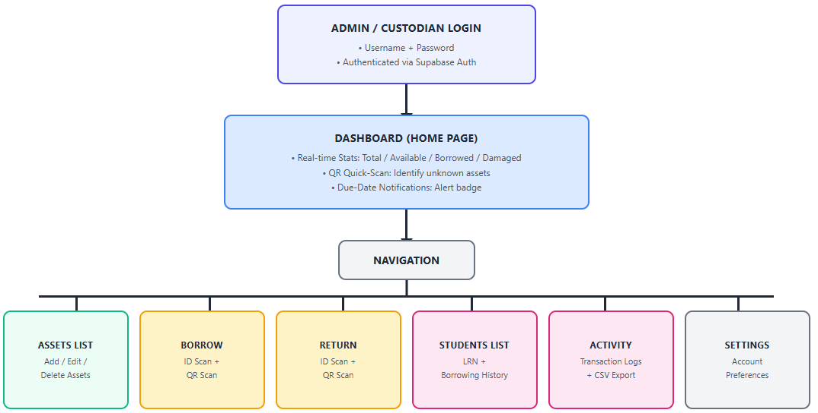
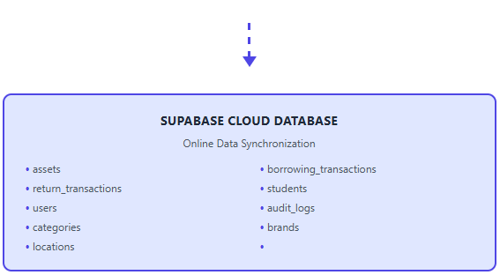

Figure 2. Project Design

Project Development
The development of the iSMART mobile application follows the Waterfall Model, which is a linear and structured software development approach suitable for projects requiring well-defined phases and clear documentation. The model ensures a systematic transformation of requirements into a functional application.

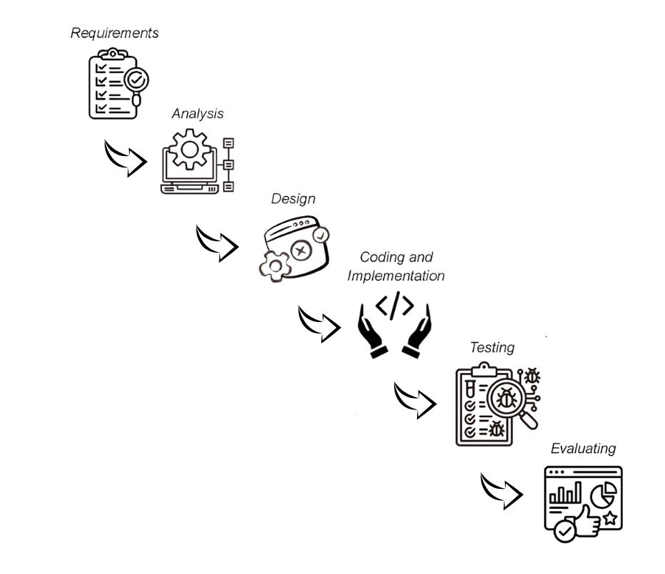

Figure 3. Waterfall Model

Phase 1: Requirements
This phase involves thorough data gathering from existing manual procedures, observation, and interviews with key stakeholders (Property Custodians, Faculty, and Administrators) to define the functional and non-functional specifications of the system.
Phase 2: Analysis
This involved the creation of the application, including the user interface layout, navigation flow and visual design. This study also planned the database structure, and content organization. The design ensured user-friendly and responsive.

A. Development Hardware (used by researchers)
Computer set with the following minimum specifications:
- Operating System: Windows 8 or higher (Windows 10/11 recommended)
- Processor: 2.20 GHz dual-core or higher
- Memory: 4 GB RAM minimum (8 GB recommended)
- Storage: 500 GB HDD or higher
Android device for testing and debugging:
- Operating System: Android 8.0 (Oreo) or higher
- Camera: 8 MP or higher (for QR/ID scanning tests)
- Internet connection: Wi-Fi or mobile data
B. Deployment Hardware (used by the Administrator and Property Custodian)
Android smartphone or tablet with the following minimum specifications:
- Operating System: Android 8.0 (Oreo) or higher
- Processor: Quad-core 1.4 GHz or higher
- Memory (RAM): 2 GB minimum (3 GB or higher recommended)
- Storage: 16 GB minimum (with at least 200 MB free for app installation)
- Rear camera: 8 MP or higher with autofocus (required for accurate QR and ID scanning)
- Autofocus support (critical for reading QR codes and printed IDs at varying distances)
- Display: 5 inches or larger, 720p resolution or higher
- Internet connectivity: Wi-Fi or mobile data (4G/LTE recommended for real-time Supabase synchronization)
- Optional but recommended: LED flash (for scanning in low-light custodial storage rooms)

Phase 3: Design
The information gathered in the analysis phase is used to specify the system architecture, database tables and relationships, and the aesthetic design (User Interface / User Experience) of the mobile application and its scanning interface. The design accounts for the mobile-first nature of the system, including touch-friendly controls, camera permissions for QR and ID scanning, and the layout constraints of Android smartphones and tablets.

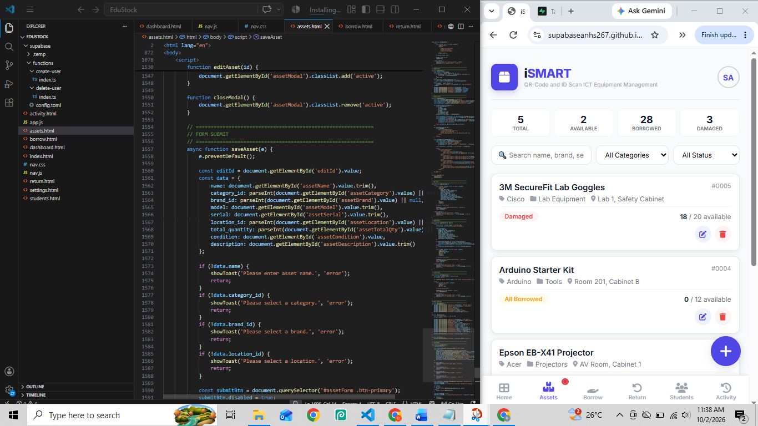
Phase 4: Coding and Implementation

The design specifications are translated into executable code, creating the various modules of the system, including the dashboard with QR quick-scan, the asset registration module, the ID and QR scanning workflow for borrow and return transactions, the student borrower registry, the transaction log with CSV export, and the notification system for due-date alerts. All modules communicate asynchronously with the Supabase cloud backend to ensure real-time data synchronization. Once coding is complete, the application is packaged into an Android APK for installation on the custodian's device.

Phase 5: Testing
Individual modules are tested (Unit Testing), followed by testing the entire system's integration to ensure all functionalities meet the initial requirements and are free from bugs and errors. The fully tested system is installed on the designated Android devices of the administrator and property custodian at Alitagtag National High School and released to the end-users for initial operation and subsequent formal evaluation.
Phase 6: Evaluation and Deployment
During this phase, respondents tested and assessed the installed mobile application based on predefined data using an evaluation instrument. The feedback gathered was used to know the strengths of the application’s acceptability and some areas for improvement before the final deployment.

Operation and Testing Procedures
The developed Mobile QR-Code and ID Scan-Based ICT Equipment Borrowing, Monitoring, and Management System is designed to provide Alitagtag National High School with an efficient and streamlined process for tracking and managing instructional ICT equipment. This section outlines how Administrators and Property Custodians (System Handlers) manage the system, and how Faculty members and Students (Borrowers) are processed through ID and QR scanning during each transaction. The procedure ensures accurate record-keeping, real-time monitoring, and effective equipment utilization.
1. Installation and Login. The administrator or property custodian installs the iSMART APK on an Android smartphone or tablet. Once installed, the user launches the app from the home screen and logs in using their username and password. The system authenticates the credentials through Supabase Authentication and redirects the user to the Dashboard.
2. Dashboard (Home Page). The dashboard displays real-time statistics such as Total Assets, Available, Borrowed, and Damaged. It also includes a QR quick-scan tool that allows the custodian to scan an asset's QR code to instantly view its details — particularly useful when the asset name is unknown. A notification badge alerts the user to assets that are approaching or past their due return date.
3. Assets Page. The Assets page shows the complete inventory with search, category, and status filters. The administrator can add, edit, or delete asset records. Each asset card displays the asset name, brand, category, location, status, and available versus total quantity. Students do not access this page.
4. Borrow Page (ID + QR Scan). The custodian scans the student's school ID to capture the name and LRN (grade level is typed manually since it appears on the reverse side of the ID), or manually types faculty borrower details. The custodian then scans the asset's QR code to confirm which item is being borrowed. The system records the borrower, asset, timestamp, and due date, and the asset status updates to Borrowed.
5. Return Page (ID + QR Scan). The custodian scans the student's or faculty member's ID to verify the borrower, then scans the asset's QR code to confirm the returned item. The system logs the return transaction with a timestamp, and the asset status returns to Available.
6. Students Page. The Students page displays the list of students who have borrowed assets, along with their LRN and transaction history.
7. Activity Page. The Activity page shows a chronological log of all borrowing and returning transactions, with CSV export functionality. It is accessible to both the administrator and custodian, although only the administrator can create or delete custodian accounts.
8. Settings Page. The Settings page allows users to manage account preferences.

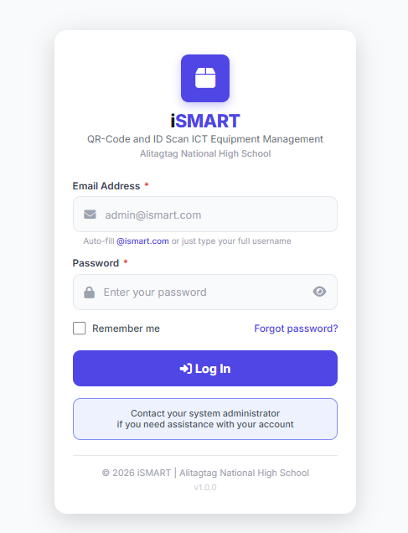

Figure 3.1 Login Interface
The Login Page is the entry point of the iSMART application. It requires the administrator or property custodian to enter their username and password, which are authenticated through Supabase. Only authorized staff can access the system; students and faculty do not log in.
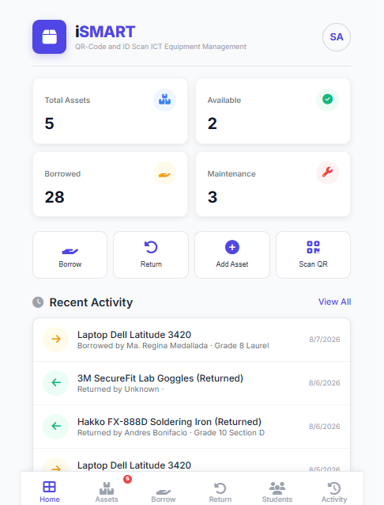

Figure 3.2 Dashboard (Home page)
The Dashboard is the main landing page after login. It displays real-time inventory statistics (Total, Available, Borrowed, and Damaged assets), a QR quick-scan tool for identifying unknown assets, and a notification badge that alerts the user to borrowed items approaching or past their due date.
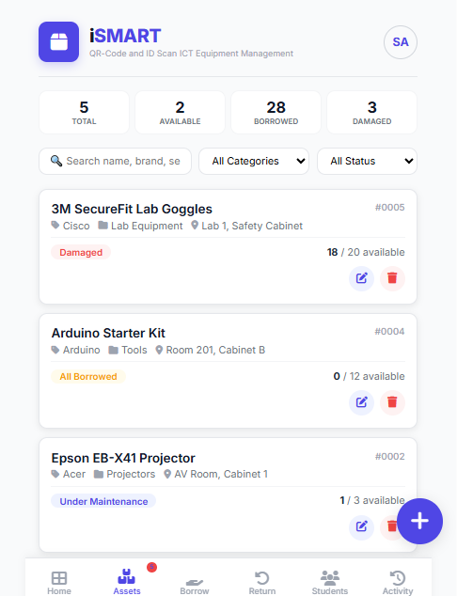

Figure 3.3 Assets Page
The Assets Page shows the complete list of registered ICT equipment. It includes search, category, and status filters. Each asset card displays the asset name, brand, category, location, status, and available versus total quantity. The administrator can add, edit, or delete asset records from this page.

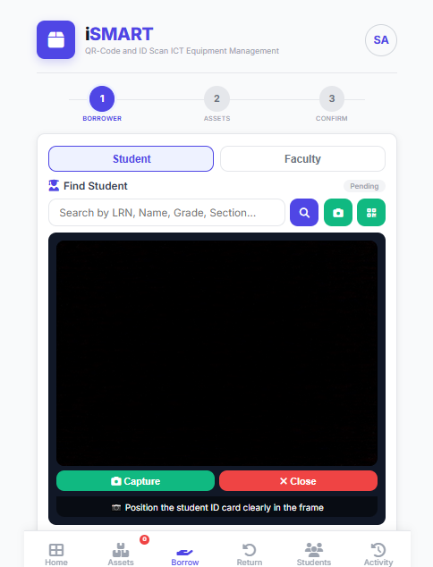

Figure 3.4 Borrow Page
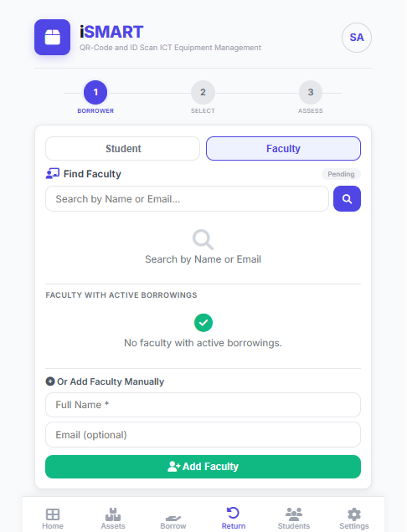
The Borrow Page is used to process equipment check-out. The custodian scans the student's school ID to capture the borrower's name and LRN (with manual grade level entry), or manually types faculty borrower details. The custodian then scans the asset's QR code to confirm the item being borrowed. The system records the borrower, asset, timestamp, and due date.

Figure 3.5 Return Page
The Return Page is used to process equipment check-in. The custodian scans the borrower's ID to verify identity, then scans the asset's QR code to confirm the returned item. The system logs the return with a timestamp and updates the asset status back to Available.
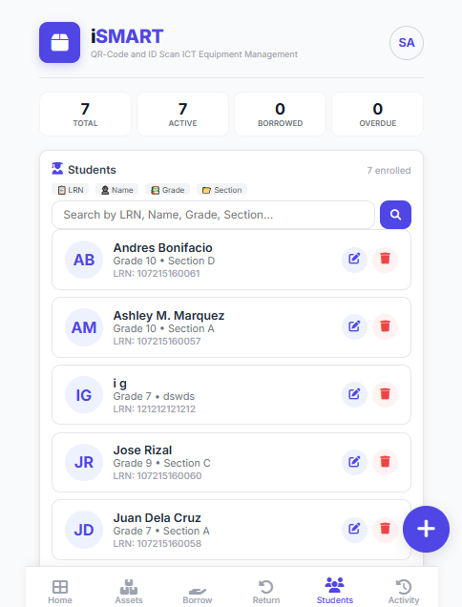

Figure 3.6 Students Navigation
The Students Page displays the list of students who have borrowed ICT equipment. It shows each borrower's name, LRN, borrowed asset, and transaction history, allowing the custodian to quickly review who currently holds which items and which are due for return.

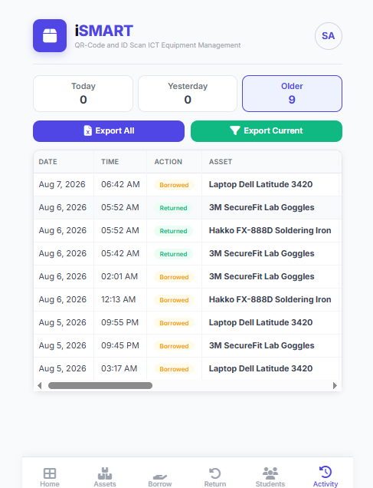

Figure 3.7 Activity Page
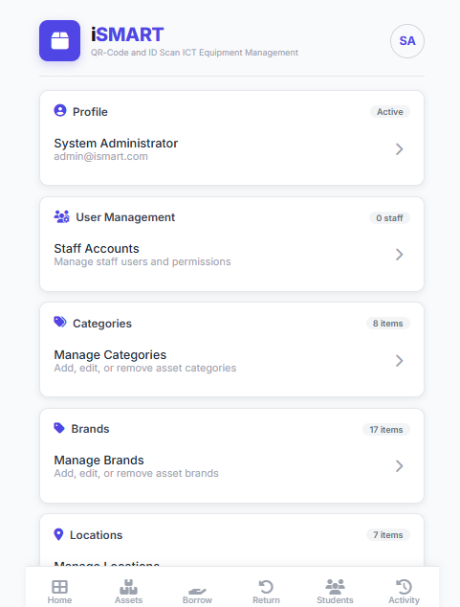
The Activity Page provides a chronological log of all borrowing and returning transactions. It records the item, transaction type, timestamp, and borrower details. A CSV export function allows the administrator or custodian to download the transaction history for reporting and auditing purposes.

Figure 3.8 Settings Page
The Settings Page allows administrators and custodians to manage their account preferences, such as updating profile information and changing passwords.

Population and Sampling
The project was conducted at the Alitagtag National High School, particularly among the faculties, administrator/property custodian, and students. The campus was chosen as the location because those respondents are the primary users and beneficiaries of the school's instructional ICT laboratory equipment, making this setting the most appropriate for evaluating the developed Mobile QR-Code and ID Scan-Based ICT Equipment Borrowing, Monitoring, and Management System. The participants of the project consisted of five (5) Alitagtag National High School faculty, two (2) property custodian, ten (10) grade 7 students, ten (10) grade 8 students, ten (10) grade 9 students, and ten (10) grade 10 students, totaling forty-seven (47) respondents. These respondents were selected because their regular usage of the instructional ICT equipment provides them with the necessary background and firsthand experience to assess the system’s compatibility, functionality, design, accessibility, and user friendly interface. The study used Stratified Sampling to ensure comprehensive representation from the target student population. The respondents were divided into 6 distinct strata—Alitagtag National High School faculties, administrator/property custodian, grade 7 students, grade 8 students, grade 9 students, grade 10 students and all members of these strata were included as participants (total enumeration within strata). This approach was implemented to gather reliable evaluation feedback from all relevant Alitagtag National High School faculties, administrator/property custodian, and student users, ensuring a robust assessment of the system's effectiveness and acceptability in managing the instructional ICT equipment borrowing process.
The study used Stratified Sampling to ensure that all relevant groups involved in the borrowing and utilization of instructional ICT equipment were adequately represented. The sampling procedure was conducted through the following steps:
1. Identification of Target Population
The researchers first identified the primary users of the Instructional ICT equipment at Alitagtag National High School, specifically the faculty members, the administrator/property custodians, and the students from Grade 7 to Grade 10. These groups were selected because they actively borrow, manage, or utilize the instructional ICT equipment and therefore possess the necessary experience to evaluate the developed Mobile QR-Code and ID Scan-Based ICT Equipment Borrowing, Monitoring, and Management System.
2. Coordination with School Administration and Property Custodians
A formal request was submitted to the school administration and the property custodian to obtain permission to conduct the study within the campus. Coordination also included requesting access to the official lists of faculty, custodians, and students in each grade level to properly establish the sampling strata.
3. Classification and Selection of Respondents per Stratum
The respondents were divided into six distinct strata: faculty members, administrator/property custodians, Grade 7 students, Grade 8 students, Grade 9 students, and Grade 10 students. All individuals within these strata were included as respondents (total enumeration within strata), ensuring that every qualified member of each group had the opportunity to participate in evaluating the developed system.
4. Invitation and Confirmation of Willing Participants
Each identified respondent was approached and invited to participate in the study. The purpose and procedures were explained clearly, and only those who voluntarily agreed and accomplished the consent form were included in the final evaluation group.
5. Finalization and Documentation of the Sample
After confirming participation, the final sample consisted of five (5) faculty members, two (2) property custodians, and forty (40) students from Grades 7 to 10, totaling forty-seven (47) respondents. These participants served as evaluators during the testing and assessment of the system. This procedure ensured that respondents were knowledgeable and directly involved with ICT equipment usage, making the sampling approach systematic, appropriate, and aligned with the objectives of the developmental research.

Evaluation Procedure
The evaluation of the developed Mobile QR-Code and ID Scan-Based ICT Equipment Borrowing, Monitoring, and Management System was conducted to determine its level of acceptability in terms of compatibility, functionality, design, accessibility, and user-friendly interface. The following steps were undertaken:
1. Preparation of Evaluation Materials
The researchers prepared the validated evaluation instruments for both student and faculty respondents, as well as the consent forms and written evaluation guidelines. All materials were reviewed for completeness, clarity, and alignment with the study’s objectives before distribution.
2. Orientation and Demonstration
A brief orientation was conducted with the respondents to explain the purpose of the study, the procedures for evaluation, and the ethical considerations to be observed. A live demonstration of the developed mobile application was also conducted, showcasing its major modules, including the dashboard QR quick-scan, ID scanning on the borrow and return pages, real-time inventory tracking, due-date notifications, and CSV report export from the Activity page.
3. User Testing and Evaluation Proper
The respondents were given sufficient time to use and explore the installed mobile application on Android devices. Administrators and custodians tested features such as item registration, transaction monitoring, and CSV report export, while faculty and student borrowers participated in ID-scanned borrow and return operations. After hands-on testing, the participants accomplished the evaluation questionnaire, rating the system based on the five criteria.
4. Collection of Accomplished Instruments
All completed evaluation instruments were retrieved and checked for accuracy and completeness. The gathered responses were then organized and secured for encoding and statistical analysis.
5. Data Consolidation and Interpretation
The encoded responses were tabulated, and statistical tools were applied to determine the overall acceptability of the system. The weighted mean was used to assess the average level of acceptability under each criterion, while the standard deviation was used to measure the consistency and variability of the responses.
Research Instruments
This study used a Likert-scale evaluation questionnaire to assess the level of acceptability of the installed mobile application. A 4-point Likert Scale was used: one (1) as Strongly Disagree, two (2) as Disagree three (3) as Agree, and four (4) as Strongly Agree. Separate but similar evaluation instruments were administered for the students and teachers to obtain a comprehensive assessment from both user and expert perspectives.
The instrument consisted of indicators under the five evaluation criteria:
- Compatibility
- Functionality
- Design
- Accessibility
- User Friendly Interface
The questionnaire underwent content validation by at least three (3) experts consisting of ICT instructors and/or research adviser. To evaluate the reliability and clarity of the questionnaire items, a pilot test was given to a small sample of respondents who were not part of the final analysis. Minor revisions were made as needed before the official deployment.
Moreover, to determine the internal consistency and reliability of the evaluation instrument, Cronbach’s Alpha was computed using the pilot-test results gathered from respondents who were not included in the final evaluation. Cronbach’s Alpha is a statistical measure used to assess how closely related a set of items are as a group, and it is widely applied in Likert-scale questionnaires to ensure that the instrument measures its intended constructs consistently. The computed Cronbach’s Alpha coefficient was interpreted using the following standard guidelines:

Table 1
Reliability Testing Using Cronbach’s Alpha
Cronbach’s Alpha Range | Interpretation
0.90 – 1.00 | Excellent reliability
0.80 – 0.89 | Good reliability
0.70 – 0.79 | Acceptable reliability
0.60 – 0.69 | Questionable reliability
0.50 – 0.59 | Poor reliability
Below 0.50 | Unacceptable reliability

After computing the values, the overall Cronbach’s Alpha of the instrument (students’ and teachers’ versions) fell within the acceptable to excellent range, indicating that the questionnaire was reliable and consistent for measuring the application’s compatibility, functionality, design, accessibility and user friendly interface. This confirmed that the items in the instrument were suitable for the formal evaluation of the developed application.

Data Gathering Procedure
This procedure outlines the systematic steps undertaken in collecting the necessary data to evaluate the level of acceptability of the developed Mobile QR-Code and ID Scan-Based ICT Equipment Borrowing, Monitoring, and Management System. The process ensured that data collection was ethical, accurate, and representative of the target respondents.
1. Securing Approval to Conduct the Study
A formal request letter was submitted to the Program Chair and ICT instructors of the Alitagtag National High School to obtain permission to conduct the study among faculty members, administrator/property custodian, and students. Approval was secured prior to the actual data gathering.
2. Validation of Research Instrument
The evaluation questionnaire was submitted to three (3) experts consisting of ICT instructors and/or a research adviser for content validation. Suggestions and recommendations from the validators were incorporated to ensure the instrument’s clarity, relevance, and alignment with the study’s objectives.
3. Pilot Testing
A pilot test was conducted with a small group of respondents who were not part of the final evaluation. The purpose of this test was to check the questionnaire’s reliability, clarity, and consistency. Minor revisions were made based on the pilot test results.
4. Evaluation
The participants were instructed to use the installed mobile application and perform necessary transactions such as scanning student IDs, scanning asset QR codes, borrowing, and returning instructional ICT equipment. Afterward, they answered the evaluation form based on their experience.

5. Retrieval and Documentation
The accomplished evaluation forms were collected and verified for completeness. All data gathered were encoded, tabulated, and organized for statistical analysis. The researchers ensured that all information remained confidential and was used solely for academic and research purposes.

Statistical Treatment of Data
The results which were collected from the survey evaluation were tallied and computed. Statistically, to analyze and interpret the evaluation results, weighted mean was used to determine the overall level of acceptability of the installed mobile application based on the respondents’ evaluation, and standard deviation was used to measure the consistency of response and the degree of variation in the evaluation ratings.
The weighted mean was used to identify the overall level of acceptability of the system based on the five criteria (compatibility, functionality, design, accessibility, and user-friendly interface).
The formula to for Weighted Mean is:
Where:
$\overline{x}$ = Weighted Mean
Ʃ = Summation
f = Corresponding score
x = Number of respondents
n = Total number of respondents
$$\overline{x}=\frac{Ʃfx}{n}$$

The Standard Deviation (SD) was used to measure the degree or variability or consistency in the responses. Greater variation in responses is indicated by a higher SD, whereas a lower SD indicates that the respondents' answers are more consistent and closer to the mean.
The formula for Standard Deviation is:
Where:
SD = Standard Deviation
x = Individual response value
$\overline{x}$ = Mean
f = Frequency of each response
n = Total number of responses

$$SD=\sqrt{\frac{{Ʃf(x- \overline{x}}^{2})}{n-1}}$$

To qualitatively interpret the computed mean scores, the following scale was used:

Table 2
Likert Scale for Evaluation of the Application
Mean Range | Verbal Interpretation
3.50 – 4.00 | Strongly Agree
2.50 – 3.49 | Agree
1.50 – 2.49 | Disagree
1.00 – 1.49 | Strongly Disagree

Ethical Considerations
The researchers ensured that all data collected were used solely for research purposes and were securely stored to protect participant privacy. Student LRN data captured during the system demonstration was treated as confidential and used solely for demonstration purposes. Because the system stores data in a cloud-hosted database, all access was protected by authenticated user accounts, and no unauthorized access to borrower records was permitted.

References
A. Electronics
Choi, H., & Lee, B. (2022). Design and implementation of an integrated inventory management system using QR codes for laboratory equipment in educational settings. Journal of Information Technology Education: Research, 21(4), 597-618. Retrieved from https://www.jite.org/documents/Vol21/JITER_Vol21_2022_597-618.pdf
Dela Cruz, R., & Garcia, L. (2023). Acceptance evaluation of a mobile-based QR code inventory system for shared resources in a Philippine state university. Philippine Journal of Science and Technology, 48(2), 110-125. Retrieved from http://philjscitech.gov.ph/journals/vol48_2/delacruz_garcia_2023.pdf
Estrada, M. (2024). Enhancing accountability and resource monitoring through digital borrowing management systems in institutional settings. Administrative Sciences, 14(7), 1-15. https://doi.org/10.3390/admsci14070090
Hasan, M., & Alam, M. (2021). Analyzing the challenges and vulnerabilities of traditional inventory systems in developing countries' public sector. International Journal of Computer Science and Network Security, 21(9), 235-242. Retrieved from http://www.ijcsns.org/03_journal/files/volume21_number9/219010.pdf
Kim, Y., & Park, J. (2023). Development and validation of a functionality scale for automated information systems in academic environments. Journal of Educational Technology Development and Exchange, 16(3), 1-20. Retrieved from https://journals.tdl.org/jetde/article/view/12001/10008
Nguyen, T., & Williams, S. (2022). The foundational trio: Roles of HTML, CSS, and JavaScript in modern client-side development. Journal of Web Engineering and Technology, 15(4), 88-105. Retrieved from https://www.jwet.org/archive/2022/vol15_issue4/jwet_2022_15_4_88.pdf
O’Connell, B., & Davies, J. (2024). Digital transformation in higher education: Streamlining asset management processes for optimized resource utilization. Higher Education Quarterly, 78(1), 123-145. https://doi.org/10.1111/hequ.12501
Singh, S., & Kaur, P. (2021). A comparative analysis of software development life cycle models in web application development. International Journal of Research in Engineering and Science, 9(1), 22-29. Retrieved from https://www.ijres.org/volume9_issue1/ijres_2021_09_01_22_29.pdf
Ahmad, F. B. (2024). Feasibility in implementing QR code inventory system. Scribd. Retrieved from https://www.scribd.com/document/730077963/Feasibility-in-Implementing-QR-Code-Inventory-System
Antic, L., & Sil, V. (2021). Continuous improvement in inventory management systems: A systematic review. European Journal of Operational Research, 290(3), 855-870. Retrieved from https://www.sciencedirect.com/science/article/pii/S037722172030806X
Choi, H., & Lee, B. (2022). The role of digitalization in optimizing educational resource management. Journal of Educational Technology Systems, 50(3), 321–338. Retrieved from https://doi.org/10.1177/00472395211059902
Dela Cruz, R., & Garcia, L. (2023). A comparative study of manual vs. automated asset tracking in academic settings. Philippine Journal of Information Technology, 8(1), 45–60. Retrieved from https://www.pjit.org/archive/v8n1/45.pdf
Estrada, M. (2024). Maximizing ICT asset lifespan through proactive maintenance scheduling. International Review of Maintenance Engineering, 15(2), 101–115. Retrieved from https://www.irmaintenanceengineering.org/article/15-2-101
Hasan, M., & Alam, M. (2021). Analyzing the challenges and vulnerabilities of traditional inventory systems in developing countries' public sector. International Journal of Computer Science and Network Security, 21(9), 235-242. Retrieved from http://www.ijcsns.org/03_journal/files/volume21_number9/219010.pdf
Ifeoluwa Oyerinde, E., Oladipo, O. B., & Ayeni, O. O. (2025). Design and implementation of a secure QR code-based attendance management system for higher education. International Journal of Scientific Research in Computer Science Engineering and Information Technology, 11(5), 77-89. Retrieved from https://www.researchgate.net/publication/395911264_Design_and_Implementation_of_a_Secure_QR_Code-Based_Attendance_Management_System_for_Higher_Education
Mohd Nasir, M. N., Mohd Zin, M. S. I., Awang Md Isa, A., & Salim, S. I. (2025). Smart asset tracking and monitoring: A practical approach for resource optimization. International Journal of Research and Innovation in Social Science, 9(9), 5141-5152. Retrieved from https://rsisinternational.org/journals/ijriss/articles/smart-asset-tracking-and-monitoring-a-practical-approach-for-resource-optimization/
Nguyen, T., & Williams, S. (2022). The impact of IT asset management on university budget optimization. Journal of Educational Technology and Budgeting, 15(4), 88–105. Retrieved from https://www.jetb.org/article/v15i4/88.pdf
O’Connell, B., & Davies, J. (2024). Digital transformation in higher education: Streamlining asset management processes for optimized resource utilization. Higher Education Quarterly, 78(1), 123-145. Retrieved from https://doi.org/10.1111/hequ.12467
Pabelona Jr., R. M., & Sermonia, C. J. G. (2025). Cloud-based inventory system with quick response (QR) tagging for technology workshop. International Journal of Research and Scientific Innovation (IJRSI), 12(1), 803-822. Retrieved from https://rsisinternational.org/journals/ijrsi/articles/cloud-based-inventory-system-with-quick-response-qr-tagging-for-technology-workshop/
Singh, S., & Kaur, P. (2021). Adoption of QR code technology for enhanced data accessibility and system efficiency. International Journal of Innovative Technology and Exploring Engineering, 10(5), 180–186. Retrieved from https://www.ijitee.org/wp-content/uploads/papers/v10i5/E86870310521.pdf
Su, C. (2022). Research on the application of information technology in university asset management. International Journal of Frontiers in Engineering Technology, 4(2), 1-5. Retrieved from https://journals.uklsc.com/index.php/IJFET/article/view/287
Sukron, M. S., Ramadhan, M. R., & Sihabillah, A. (2024). Streamlining inventory management with QR technology: Introducing the supply and equipment tracking system. International Journal of Engineering Research and Computer Science Engineering, 4(8). Retrieved from https://ijercse.com/article/4%20August%202024%20IJERCSE.pdf
Wijesena, G. H. D., & Amarasinghe, R. (2023). Design and evaluation of an innovative mobile solution: QR code-based inventory monitoring system. International Journal of Advanced Engineering and Management Research, 8(3), 231-237. Retrieved from https://www.ijaemr.com/uploads/pdf/archivepdf/2023/IJAEMR_578.pdf
Yaqin, M. A. (2023). Development of a QR code-based inventory system and consumable material management using Django Python. Jurnal Kesehatan Terpadu, 14(1). Retrieved from https://jurnal.unimus.ac.id/index.php/ICHI/article/view/15578/0
Supabase. (2024). Supabase documentation: The open-source Firebase alternative. Supabase Inc. Retrieved from https://supabase.com/docs
Ionic Team. (2024). Capacitor: Cross-platform native runtime for web apps. Ionic. Retrieved from https://capacitorjs.com/docs

